**Tour Singapore - Kuala Lumpur**

*Attention:*

-Departure point: Hanoi.

-Time: 6 days 5 nights.

-Media: aircraft.

-Tour price:10690000đ

-Images:

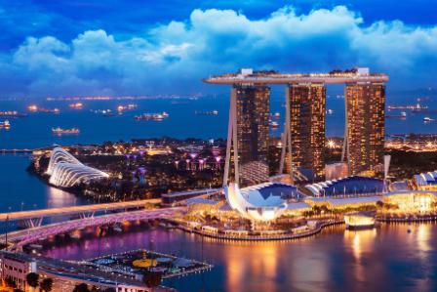 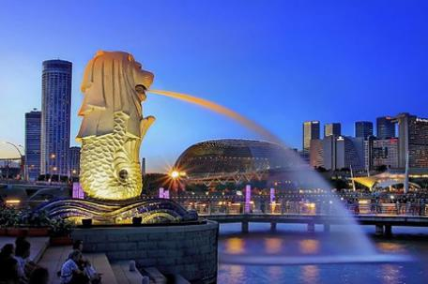 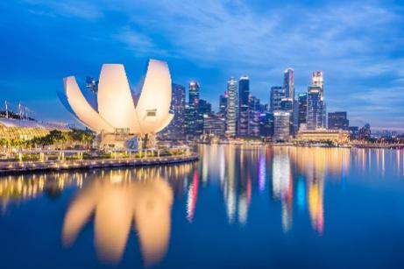

**I.Introduce:**

**TRAVELING TO SINGAPORE**

**Singapore is known as the "cleanest" dragon and city in Asia, where you will discover ancient traditions in harmony with modern development trends. Not as bustling and noisy as some other capitals but Singapore - the small and tidy country, the annual sophistication always attracts tourists far beyond their population.**

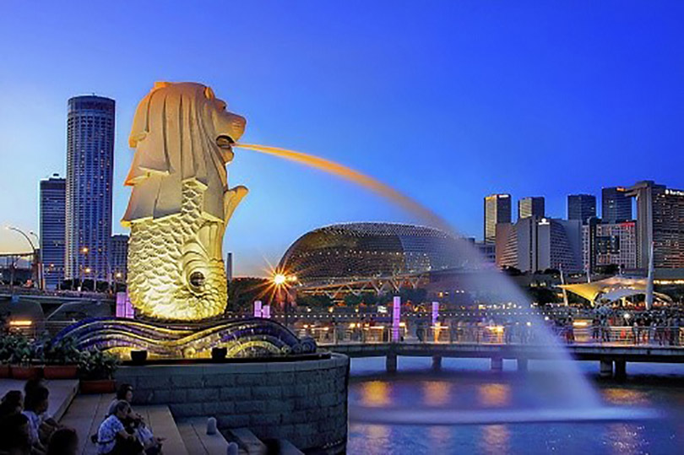

Coming to **Singapore**, Sentosa Island cannot be missed, where there are many unique attractions, where there are sea lions, the symbol of the country. The monorail ride gives visitors a panoramic view of Sentosa. Here besides the beautiful beach, there is Jurong bird garden, underwater world, water music area, wax museum ...

**Kuala Lumpur** is the largest city and the capital of Malaysia. Kuala Lumpur is one of the three territories of the Federation of Malaysia, located in the land of the state of Selangor, mid-west of Peninsular Malaysia. Malai people call this city KL for short. With the completion of the Putrajaya construction in the late 90s of the 20th century, the role of the administrative and judicial capital of Kuala Lumpur was transferred to this new city although some judicial agencies were still located in KL. The Malaysian Parliament is still active in KL, so the city remains Malaysia's legislative capital. Kuala Lumpur currently has an area of 243.65 km2 and a population of 1,479,388 people.

**II.Tour schedule:**

**1.Day 1:**

**HaNoI – SINGAPORE**

_____________________________________________________________________

**10h00**: Pick up at the Hanoi Opera House departure to Noi Bai airport. Delegation to Noi Bai airport, procedures for flight TR301 at 13h10 to Singapore.

**17h40**: Arrive at Changi Airport (Singapore), the delegation do entry procedures for Singapore. Bus transfer to the hotel and check in and rest. Group dinner.

Overnight at Days Hotel or Holiday Inn Katong or similar.

If time allows you, along with local guides to participate in the exciting and new Singapore Singapore Night Discovery program such as: Discover the underground life of Singaporeans by Underground MRT, Cruise Experience on the Singapore River views the Marina Bay at night, Explore Suntec City Shopping Center - learn about Feng Shui Upper - Lower Feng Shui of Singapore (expenses excluded). _____________________________________________________________________

**2.Day 2:**

**SINGAPORE – SENTOSA - JOHOR BAHRU** _____________________________________________________________________

After breakfast, the delegation began to visit: Special ecological garden named Bay South Gardensby the Bay - with solar "super tree" system, the largest ecological park project in Singapore to enhance quality of life, keep the green for busy urban. The whole project has a total area of ​​101 hectares, divided into 3 separate areas: Bay South, Bay East and Bay Central (only visiting the South Bay area, excluding tickets to the gardens in the greenhouse). Continue the journey to visit: Historical Parliament Building, Supreme Court, City Hall, Esplanade Theater, Marina Bay Bay, Sea Lion Park Merlion Park ...

After that, the delegation will visit and shop at: Diamond, gold, silver and gemstone processing workshop, wind oil shop + skincare collagen - unique traditional and famous products of Singapore.

Group lunch at the restaurant. Continue to the famous tourist island Sentosa. Merlion Tower sea lion tower (outside shooting). Visit Madam Tussuads 3 in 1 with: Wax Museum (Madame Tussauds) - There are beautiful wax statues that are exquisitely carved in exactly the same way as the "prototype" The statues are made to every centimeter and have faces very expressive as: Two famous football players David Beckham and Cristiano Ronaldo; Basketball star Yao Ming has a height of 2.29 m; contemporary music stars such as Taylor Swift, colored diva Beyonce, Katy Perry, Michael Jackson or Madonna; legendary actors Marylin Monroe, Audrey Hepburn or martial arts film star Jackie Chan; A-list couples in Hollywood are Brad Pitt and Angelina Jolie. Images of Singapore live - A place to recreate the everyday life of Singaporeans from primitive to modern. With beautiful wax sculptures exquisitely carved with dimensions, colors, costumes and charisma just like real people through community activities, customs, rituals, ... Come here you will experience the journey back in time to learn about Singapore history. You get on a boat called "The Spirit of Singapore" - wonderful boat, splendid discovery of Singapore's wonderland.

After that, depart for Malaysia, arrive in Johor Bahru, have dinner, check in hotel and rest.

Overnight at Hall Mark Regency 3 stars or equivalent. _____________________________________________________________________

**3.Day 3:**

**JOHOR BAHRU – MALACCA**

_____________________________________________________________________

After breakfast, the delegation check out. You are free to shop at the Premium Outlet - the address to hunt for cheap fashion goods for young people, but even Singaporeans are also devotees of this mall. Here, visitors can hunt for brand name at unbelievably cheap prices, often discount 25-65% at 80 stores with big brands like Gap, Nike ...

Have lunch, depart for Malacca. Upon arrival, explore the Dutch Square - A small park with the simulation of a windmill and green clusters of trees dotted with flowers to remind the Dutch period of reign here, Fortress. Ancient Portugal, Old Church of St. Pauls ...

Dinner, rest and check in hotel.

Overnight at hotel in The Straits 3 stars or equivalent. _____________________________________________________________________

**4.Day 4:**

**MALACCA - KUALA LUMPUR**

_____________________________________________________________________

After breakfast, you check out, move to Kula Lumpur.

Visit Putrajaya - where information technology coexist with the lush gardens. Malaysians proudly call Putrajaya a smart city.

Group lunch to enjoy Korean BBQ buffet hot pot.

You visit the beautiful capital of Kuala Lumpur: Twin Tower - is the pride of the people of Malaysia from the time it appeared. 88-storey tower - built by Malaysia's most powerful oil and gas group was once considered the tallest tower in the world, the Royal Palace, Monument, Independence Square, Thien Hau Pagoda.

Visit and enjoy Chocolate at the famous Chocolate Shop - Bery’s Malaysia.

Overnight at hotel at Pudu Plaza 3 stars or equivalent. _____________________________________________________________________

**5.Day 5:**

**KUALA LUMPUR – HIGHLANDS GENTING – KUALA LUMPUR**

_____________________________________________________________________

After breakfast, the coach and tour guide take the delegation to visit Batu Caves - the sacred place of Hinduism of the ancient Indians with 272 steps leading to the cave temple. local produce, Duty Free Shop, Jewelry Shop, especially learn about Malaysia's national treasures.

After lunch, depart for Genting Highlands. Coming to Genting plateau, the cable car takes you to the top of the plateau with the height of 2,000m above sea level, you begin to explore the lively world here.

You can shop, try your luck at the famous Genting Casino in Southeast Asia, participate in games such as motorcycling, high-speed aerial trains, photo shoot in the snow house ... (chi own expense). Depart for Kuala Lumpur.

Group have dinner at restaurant.

Overnight at hotel at Pudu Plaza 3 stars or equivalent. _____________________________________________________________________

**6.Day 6:**

**KUALA LUMPUR – hanoi**

_____________________________________________________________________

Group breakfast at the hotel. After that, the car will take the delegation to the airport to complete procedures to take flight OD571 of Malindo Air airline to Hanoi at 09h20.

11h25: The plane landed at Noi Bai airport, the car takes you to the meeting place. Farewell union wraps up _____________________________________________________________________

**III.INCLUDED AND TERMS:**

**Rates include:**

Return flight Hanoi - Sin // Kul - Hanoi airline security surcharge of Scoot Air & Malindo Air

Fees for the two international airports;

20kg checked baggage and 07kg hand luggage;

3-star hotel (room for 2 persons - in case of an individual group, a room of 3 persons / 3 beds);

Meals according to the program;

Newly air-conditioned tourist cars in Vietnam and abroad;

THERMAL GUIDELINES - CHUOO - HONESTY during the tour to ensure the smoothness of the trip for groups of 15 guests or more. The delegation has less than 15 guests, local guides and guides to see off the airport in Vietnam;

Travel insurance during the time of staying abroad 24h / 24h including luggage, compensation up to 10,000 USD / case / person;

Beauty tickets (one-time admission).

Tax for tourists traveling to Malaysia from 1/9/2017 is 5usd;

**Not included:**

Personal expenses, drinks, excess baggage, telephone charges, laundry, VAT

Tip 3 USD / 01 person / 01 day x 06 days = 18 USD / person

**Note:**

The above fee applies to customers holding Vietnamese passports (valid passports over 6 months from the date of departure). Guests with foreign passports, please check back.

The above program may vary in time and schedule, but still ensure the above attractions.

Airport according to the schedule of the whole group, if there is a change after ticket issuance, the ticket will be no longer valid. The final time depends on the airline.

Unused services without notice will not be refunded.

The above program is a pure tourism program, you need to combine the work, please notify clearly when registering.